THOUGHT LEADERSHIP | PRODUCT LEARNING
Building a Reuse Marketplace App
  - What We Learned Trying to Make Free Stuff Reused
An honest evaluation from the creators of Dumpick – a mobile app built to connect curbside reusable items with people who need them. Written for founders, product owners, and NFP builders addressing similar social challenges with digital products.

App | Dumpick - free curbside reuse marketplace
Platform | iOS & Android (live https://mrkloudfoundation.org )
Org structure | Registered Not-for-Profit (Australia): MR Kloud Foundation Ltd
Core stack | Serverless, GraphQL, React Native
Period covered | 2019 – present
Status | Live but not yet at self-sustaining scale
Grant secured | AUD 10,000 (local council)  Microsoft – AUD 3.5k worth of Azure usage annually, Office 365 including sharepoint online access.  Amazon – USD 1000 worth of annual credit (Via Connecting Up).  Google grant for ads – USD 10,000 a month (With constraints)
Author | Co-Founders (Rahul Rahul and Muhammad Mahdi Hasan) MR Kloud Foundation Ltd.

Executive Summary
Value creation with a good social mobile app with genuine social and environmental intent turns out to be far more challenging and complex than building the app itself. Dumpick, the mobile app, was built to solve a real, measurable problem: curbside reusable items ending up in landfill while people nearby could have used them. The hypothesis was sound. The problem was real. Technology worked.
What we are still struggling with is the growth loop. A two-sided marketplace with no supply density (In this case number of posts against curbside items), no embedded distribution trigger*, and limited runway for incentive experiments is an extraordinarily difficult cold-start problem, regardless of the best intentions behind the product.
This document is not a post-mortem. Dumpick is still live. It is an honest account of what we attempted, what we learned, and what we would do differently. We hope this document will serve as a learning document for other founders, NFP builders, or civic tech teams who are contemplating a similar platform and want to learn from our experience rather than repeat it.

*A distribution trigger needs to complete
Dumpick includes a share function, which when used, the recipient sees the item, its location, and a photo, attributed to Dumpick by name. Two of the three ingredients for viral distribution were present: awareness and a curiosity hook (a free item nearby). The third ingredient is missing. There is no download link, no deep link, no frictionless path from "I saw this" to "I am now a user."
For builders: a share button is not a distribution trigger. A distribution trigger is a share button plus a conversion path that works in the same moment the interest is live.

What Dumpick taught us about cold-starts
Cold start is a liquidity design problem: without dense, local supply, demand never forms. Volunteer seeding doesn't work without incentives; values don't compress into action without structure. Trust, logistics, and measurement are product features, not assumptions. Councils fund but don't distribute; underfunding demands fewer bets with harder criteria, instead of building more product features.

The Problem
Curbside collection, practice of leaving reusable household items on the footpath for council pickup, generates a growing volume of landfill and recycling burden across Australian cities. Publicly available data confirmed an increasing rate of council collections in Victoria and beyond, translating directly into higher collection costs, greater environmental pressure, and the waste of items that still have plenty of useful life.
At the same time, a specific group of people, including recent migrants, students, people practicing circular economy, anyone watching their budget could genuinely benefit from access to these items. The gap between supply and demand existed purely because of timing and visibility. Items sat on curbs. People who needed them had no way to know.

The core hypothesis
If we surface curbside items in real-time via a mobile app, we reduce landfill, reduce council collection burden, and give free items a second life. Nearly everyone owns a smartphone. The solution seemed to be both low-friction and high-impact.

The Solution - Dumpick

MVP (2019-2020)
Our goal was the simplest possible product with a seamless experience: no login barrier, no complexity, just a way to post items and browse what was nearby. We defined “done” as shipping something usable and targeting 1,000 users within three months of launch.
We chose a low-cost serverless architecture which was easy to iterate, familiar enough to move fast, low operational overhead. The frontend was built in React Native to serve both iOS and Android from a single codebase, developed with a freelancer sourced from Upwork within a tight budget. The to-and-fro with the freelancer, compounded by time-zone differences and requirements alignment, added more friction than anticipated, a pattern worth flagging for others working the same way.

Funding and Legal Setup (2021)
With a product roadmap that extended well beyond the MVP, we needed both credibility and funding. We pitched the app to four local councils. Three of them were cautious and risk averse. One recognised the community value and awarded us AUD 10,000 grant which was a meaningful validation and a genuine morale boost.
We used those funds to establish a registered Not-for-Profit entity, publish the app on both app stores, engage a lawyer for legal structure, and begin marketing experiments. Subsequent applications to three further grants (private and public) were unsuccessful.

Iterative Improvements (2021–2023)
With no organic growth from the MVP alone, we continued building from the roadmap, adding phone-number login for moderation and spam control (without blocking read access, keeping it largely open), integrating Google Maps for location-based item discovery, and implementing push notifications via Firebase to re-engage users when new items were posted.
These were reasonable product decisions. The problem was that each feature improvement addressed usability, not the underlying adoption loop.

Go-to-Market: What We Tried

Paid Digital
With Google Ads credits secured through the council grant, we engaged freelancers for conversion-to-download campaigns. Google’s advertising limitations meant we could only track clicks to our website, not conversions to app installs in the marketplace. The channel provided website traffic, not install growth.

Physical Flyers and Community Spaces
We designed and printed flyers at multiple sizes, placing them in community libraries, college campuses, and through manual street distribution. This generated awareness in pockets but required sustained effort and produced minimal measurable download lift.

Volunteer Seeding
We ran three separate waves of volunteer recruitment to seed item posts and create the appearance of supply in the app. The waves yielded almost no output. The volunteer community showed no meaningful interest in the task. Registering with volunteering organisations for broader support also produced no traction.

Events, Webinars and Council Outreach
We attempted to present at Melbourne meetups but most requests for speaking slots went unanswered, ran a webinar that was well-received but did not convert to downloads. We also continued persisting with email outreach to councils. The reception was warm; the downstream action was not.

What the Data and Experience Show
Across all channels and all efforts, the pattern has been consistent:

- Installs follow almost entirely with specific events (a volunteer briefing, a strong LinkedIn post). No event, no installs.
- More than 95% of posts in the app have been created by the two founders. Organic supply generation from the community never materialised.
- Even though awareness and appreciation of the problem are high, there has been negligible conversion from awareness to install.
- We lack analytics infrastructure to see install/uninstall behaviour and retention, which makes diagnosis difficult.

The Funnel Reality
Most people we spoke to understand the problem and said the app was a great idea. That enthusiasm has not been translated into downloads, and even a handful of downloads have not been translated into posts. The loop is not closed.

Why It Has Not Scaled (Yet)

Cold start is a liquidity design problem, not a marketing problem
Reuse marketplace is two-sided: you need supply (item posts) before demand (browsers) will return. Without a critical density of posts in a specific geographic area, downloads don’t happen despite the awareness. Our posts peaked at 200–1,000 items but were geographically scattered and not organically generated. There was no density loop.

Volunteer supply does not work without structure or incentive
We assumed that people who cared about the environment would volunteer their time to seed the app. That assumption was wrong. Posting items require a specific physical trigger (being near a curbside item), a phone, the app, and the motivation to act. Without deliberate incentives, such as gift cards, community credits, partner rewards, etc., that chain rarely completes. We cannot equate volunteers posting items with the ones donating blood.

Trust and logistics are product features, not assumptions
Our app has no claiming mechanism. Users browsing items have no way to confirm whether an item was still available, in what condition, or whether someone else is already on their way. The risk of a wasted trip is a genuine deterrent. We treated trust and logistics as assumptions, which are usually a core feature from the start.

Councils fund but rarely distribute
A grant is a meaningful signal of problem validation and provides runway. What councils rarely do is actively market a third-party product on your behalf, even the one that directly benefits their constituents. Legal caution, risk aversion, and organisational inertia prevent it. Treat councils as policy enablers and data sources (rubbish day calendars, pilot venues), not as a promotional channel. Think of collaborating with them rather than marketing through them.

Offline awareness does not equal app installs
Flyers and word-of-mouth create passive awareness. App installs require an embedded, urgent trigger: a specific event, a QR code at a hard-rubbish pile, a partner workflow that puts the app in someone’s hand at the moment they need it. Without urgency and a direct install pathway at the point of awareness, interest stays passive.

Feature improvements do not substitute for missing loops
Login, map view, and push notifications were all reasonable improvements. None of them addressed the core problem: there was no self-reinforcing loop connecting posting, discovery, collection, and referral. Product roadmap work must be tied directly to measurable loop metrics, not just usability improvements.

Without measurement, you cannot diagnose
We did not have end-to-end visibility on installs, uninstalls, or retention, partly due to platform constraints, partly because we did not build analytics into the MVP definition. For any civic platform, measurement is not a nice-to-have. It is how you know whether you are making progress at all.

Underfunding forces scope discipline
Limited funding constrained paid channel experiments, incentive programs, and the ability to hire the right skills at the right time. The practical response to underfunding is not to try more things. Instead, it is to do fewer things with harder success criteria. We should have gone hyper-local far earlier, with explicit pass/fail metrics for a single suburb or campus before attempting anything broader.

Key Learnings for Builders
If we were starting over, or advising someone to build a similar civic marketplace, these would be the non-negotiable lessons:

Start hyper-local and prove the loop first
Pick one suburb, one campus, or one community with a known high density of relevant supply. Seed it yourself. Door-knock. Demonstrate the loop in that one location before thinking about scale. Geographic constraint is a feature, not a limitation.

Build distribution into partnerships from day one
Property managers, student unions, moving companies, op shops, and council hard-rubbish teams are natural partners who already touch the exact moments that drive supply and demand. Build for them first. Let them embed the app in their workflow.

Incentivise supply before expecting organic demand
Posting an item requires effort. Gift cards, community credits, or small monetary rewards for verified posts are not a crutch, they are a mechanism for proving whether the loop can close. Prove incentives work at small scale before eliminating them.

Make claiming and logistics a core product feature
Any marketplace for physical goods must resolve the question of “is this still available?” before users will act. Reservation windows, status updates, and collection confirmation should be part of core features.

Analytics must be in the MVP definition
Install rate, activation, retention, and successful collection confirmation should be implemented from day one. Without this, you cannot know where the funnel breaks, and you will spend energy improving the wrong thing.

Define a growth loop before building features
The loop should be: post -> discover -> collect -> confirm taken -> share or repeat. Every feature decision should be evaluated against whether it tightens that loop. If it does not, it waits.

Achievements
Scaling challenges aside, there are genuine achievements worth naming:
- Ideation to going live: With full-time jobs, limited budget, and no prior startup experience, we designed, built, and shipped a functioning two-sided mobile marketplace on two platforms within a year.
- A legally registered and responsibly run NFP: We created the organisational structure, engaged legal counsel, registered the entity, and have continued to run it responsibly. This was not a small undertaking for a bootstrapped team.
- External validation and grant funding: Pitching to councils and securing AUD 10,000 grant proved the problem resonated with at least one decision-maker willing to back it with real money.
- Navigating real-world constraints: We learned, hands-on, how volunteers behave (or don’t), how councils operate, how freelancer collaboration works across time zones, how app stores work, and how marketing limitations shape what is actually possible.
- A reusable framework for others: The mistakes, decisions, and lessons documented here are transferable. If this paper prevents another team from spending six months on the wrong assumptions, it has done its job.

What We Would Do Differently

What we did | What we’d do instead
Broad geographic launch from day one | Launch in one high-density suburb; prove the loop before expanding
Hoped volunteers would supply posts | Incentivise posting with gift cards or credits from the start
Assumed awareness converts to installs | Build embedded triggers: QR codes at hard-rubbish piles, partner onboarding moments
Built features to improve usability | Tie every feature decision to a measurable loop metric
Relied on councils as marketing channel | Treat councils as data/policy partners only; built independent distribution
Analytics left for later | Instrument install, activation, retention from MVP day one
Pitched widely for funding early on | Run a tight, funded experiment in one location and use the results as proof for the next grant.

Conclusion
Dumpick is still live. The app is available on Android and iOS. The problem it was built to solve, i.e. curbside reusables ending up in landfill while people nearby could use them, still exists.
What has not happened yet is the self-sustaining adoption loop that would allow the platform to grow without continuous founder-driven effort. That gap is not primarily a technology problem or a product quality problem. It is a cold-start, distribution, and incentive design problem that every civic marketplace builder will face.
We are sharing this experience not to signal that the idea is exhausted, but because of the pattern of challenges i.e., two-sided cold starts, volunteer supply failure, trust gaps in physical logistics, council partnership limits, and the trap of feature-building without loop measurement is likely to recur for anyone building in this space.
If you are building something similar and want to compare notes, the conversation is worth having.
Builders: Please connect via LinkedIn: https://www.linkedin.com/company/mrkloudfoundation/
And feel free to send your thoughts on the app: https://mrkloudfoundation.org/dumpick

Appendix: Technical Reference

System Overview
The architecture was designed around three principles: low cost, low operational overhead, and fast iteration, all appropriate constraints for an early-stage adoption experiment with limited funding.
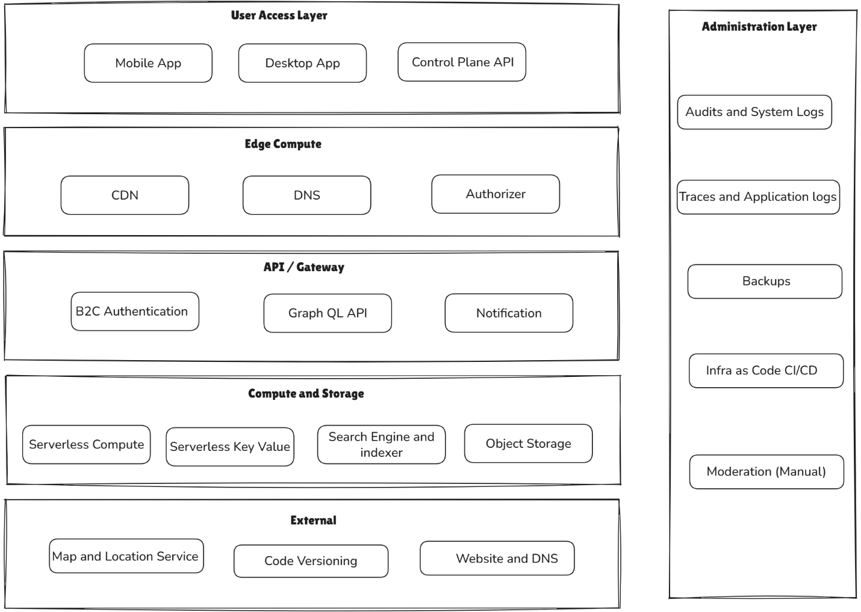

Key Architectural Decisions
Decision | Rationale and trade-off
Serverless-first | Low cost and fast to iterate; trade-off was local testing complexity and cold-start latency
GraphQL API | Flexible mobile queries without over-fetching; trade-off was schema discipline and coupling
No-login MVP | Reduced onboarding friction; trade-off was spam and moderation risk
Login added later | Needed for moderation at scale; trade-off was increased onboarding friction
Google Maps integration | Improved location-based discovery; trade-off was location precision and privacy considerations
Push notifications (Firebase) | Re-engagement when new items posted; trade-off was careful opt-in UX required
Minimal PII (phone + ID only) | Privacy-preserving and safe; trade-off was limited trust signals between users
Client-side image upload pipeline | Kept the mobile client lightweight; trade-off was storage and moderation overhead

Testing Approach
A lightweight Java desktop harness was built to simulate client calls and validate API behaviour, particularly useful for testing GraphQL request/response patterns and core workflows (create post, fetch latest, query by area, update status) without requiring a mobile device for every regression check. A sanitised version is available for reference. Feel free to contribute.
https://github.com/rahulrahul-org/appsync-java-client

